Tesla Small Front Drive Unit

The tesla front drive unit is an extremely compact motor that is able to perform well. These motors come from crashed tesla vehicles and are then refurbished, reprogramed, and fully tested.
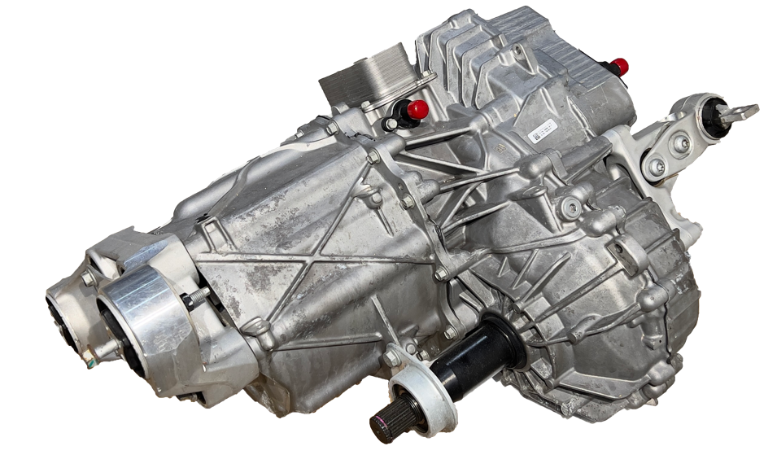

Features
400Vdc maximum voltage
Integrated differential
9.34: 1 gearbox ratio

Integrated water pump

Main Specifications
Peak Torque | 330Nm
Peak Power | 220kW
Continuous Power | 90kW
Maximum Speed | 18000rpm
Weight | 90kg
Motor Cooling Medium | Dexron VI
Inverter Cooling Medium | 50% E.G. / 50% Water
Combined Efficiency | 92%

OILING INFORMATION
All Tesla Front drive units are shipped filled with oil. Procedures below for reference.
Approved Oils
- Dexron VI ATF(preferred)
- Transynd ATF (Synthetic Formulation of Dexron VI Made by Mobil 1)
- Shell Spirax S6 ATF A295 (made by Shell for ATF Application)
- Lubrizol OS183539V
- BASF (manual transmission fluid)

